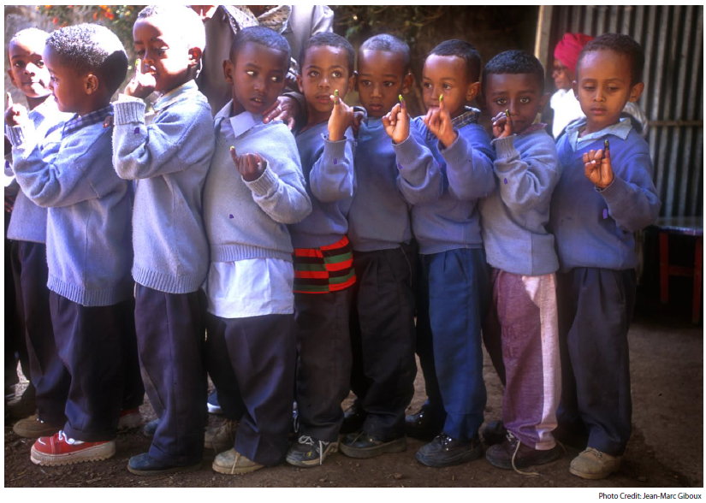

PURPLE PINKIE DAY
IS COMING!

______________________ _________________ ____________________
MONTH DAY YEAR

